**Grade 7 Literature (Prose)**

**October 12-24, 2020**

**Content:** Literature may be defined as any body of written works. It may also refer to writings that are considered an art form often due to the use of language in ways that differ from everyday usage. There are three genres of Literature; Prose (Stories), Poetry (Poems) and Drama (Plays)

***Prose*** is a form of language that possesses ordinary syntax and natural speech, rather than a regular metre; in which regard, along with its presentation in sentences rather than lines, it differs from most poetry. Prose Fiction include novels, novellas, short stories etc.

***Poetry*** is a form of literary art which uses the aesthetic qualities of language (including music and rhythm) to evoke meanings beyond a prose paraphrase. Poetry has traditionally been distinguished from prose by its being set in verse; prose is cast in sentences, poetry in lines; the syntax of prose is dictated by meaning, whereas that of poetry is held across meter or the visual aspects of the poem.

***Drama*** is literature intended for performance. The form is often combined with music and dance, as in opera and musical theater. A play is a subset of this form, referring to the written dramatic work of a playwright that is intended for performance in a theater; it comprises chiefly dialogue between characters, and usually aims at dramatic or theatrical performance rather than at reading.

**Activity:** Assign the appropriate genre to the following extracts.

1. I come with no wrapping or pretty pink bows.   
   I am who I am, from my head to my toes.   
   I tend to get loud when speaking my mind.   
   Even a little crazy some of the time.
2. Sarah sat quietly by the water, her feet moving in tiny circles as the fishes passed. Sitting by the river was her favourite thing to do. It was a way for her to escape the outside world and forget about her problems for just a moment.
3. Ryder: Hark! Who goes there?

Helen: Tis but I my lord. [*she slowly makes her way into the light]*

Ryder: My lady *[he takes her hand and kisses it]* Thy beauty is like no other in the land.

Helen: *[Pulls hand away]*

**WEEK 2**

**Content:** Chapter 1 -Oliver Twist is born in a workhouse with the help of a drunken nurse and the parish surgeon. His mother, who they had found on the streets that night, has no wedding ring and after kissing her child on the forehead, dies.

**Activity**: Watch a video to obtain background information on the author <https://www.youtube.com/watch?v=gsVzpAN2jhY>

Write a Chapter summary in your own words on what you read from Chapter 1

**Grade 7 Literature (Poetry)**

**October 12-24, 2020**

**Content:** Elements of Poetry

Theme- Poetry has an overall central theme or idea within each poem

Couplet - two lines of verse that rhyme at the end and are thought as one unit

Meter - A rhythm that continuously repeats a single basic pattern.

Rhyme - Words that end with similar sounds. Usually at the end of a line of the poem.

Stanza - A part of a poem with similar rhythm and rhyme that will usually repeat later in the poem.

Verse/Line - A line of a poem, or a group of lines within a long poem.

**Activity: Identify the parts of a poem using the poem below**

*“ I've hunted near, I've hunted far  
I even looked inside my car.  
I cannot say where they could be,*

*I need them so that I can see*

*I've lost my glasses, I'm in need,  
To have them now so I can read*.

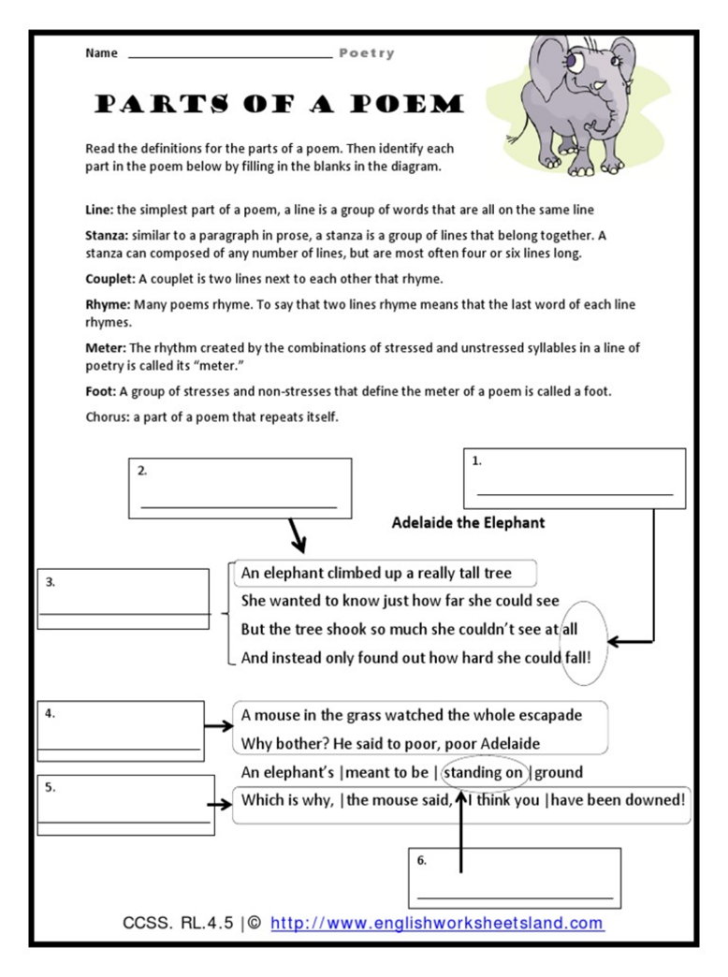

**WEEK 2**

**Content Summary:** It is he first day of school and various parents have come to take their children to meet their new teacher. Michael is introduced by his mother Sarah Pool.

**Resource Material:** Sunsong 1 (New Scholar by Louis Bennette)

**Activity:**  In groups students will be asked to translate the poem to Standard Jamaican English, one stanza at a time.

Students will answer the comprehension questions: *Why has Sarah Pool come to see the teacher?*

*What things in the poem made you laugh? What type of person is Sarah Pool? How does she feel about her son?*