MATHEMATICS
GRADE 10: LECTURE 1
MATRICES

- What is a Matrix?

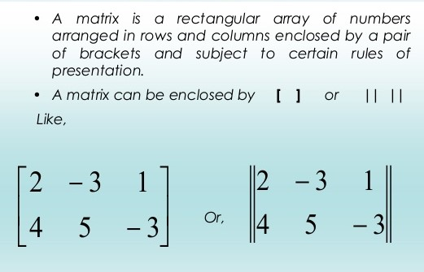

The elements in a matrix may consist of numbers, letters, fractions or decimals.

Other examples of matrices:

- $\left[\begin{matrix}3 & 4 \\ -2 & 7\end{matrix}\right]$

- $\left[\begin{matrix}a & b & c \\ d & e & f\end{matrix}\right]$

- $\left[\begin{matrix}6 & c \\ t & -4\end{matrix}\right]$

- $\left[\begin{matrix}\frac{1}{2} & 4 \\ \frac{3}{2} & \frac{11}{5} \\ 3 & -7\end{matrix}\right]$

- $\left[\begin{matrix}\frac{3}{2} & \frac{6}{11} \\ \frac{4}{3} & \frac{1}{2} \\ \frac{1}{4} & \frac{9}{11}\end{matrix}\right]$

- $\left[\begin{matrix}0.4 & 3 & 9 \\ 10 & 16 & 5 \\ 0.3 & -8 & 0.5\end{matrix}\right]$

Important definitions

- Row is moving from left to right or horizontal movement.
- Column is moving up and down or vertical movement.
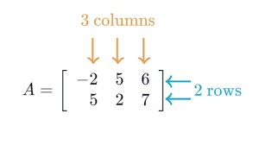
For example: -2 is in row 1 and column 1, 2 is in row 2 and column 2, 6 is in row 1 and column 3

- What is the order of a matrix?

The order of a matrix is rows times columns or rows by columns.

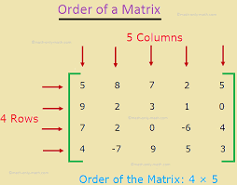

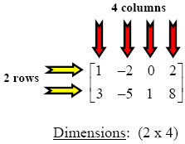

- What are the types of Matrices?

Some types of matrix include:
- Square Matrix: in this type of matrix the number of rows is equal to the number of columns.

$$\left[\begin{matrix}-9 & 3 \\ \frac{1}{2} & 4\end{matrix}\right]$$

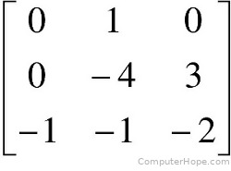

- Null matrix: all the elements in this type of matrix are 0 s.
$\left[0\right]$

$$\left[\begin{matrix}0 & 0 \\ 0 & 0\end{matrix}\right]$$

$$\left[\begin{matrix}0 & 0 & 0 \\ 0 & 0 & 0 \\ 0 & 0 & 0\end{matrix}\right]$$

- Row matrix: This type of matrix ONLY consists of one row.

$\left(\begin{matrix}-1 & 3\end{matrix}\right)$ or $\left(\begin{matrix}3 & 4 & 5\end{matrix}\right)$ or $\left(\begin{matrix}a & b\end{matrix}\right)$ or $\left(\begin{matrix}x & y & z\end{matrix}\right)$

- Column Matrix: This type of matrix consists of ONLY one column.

$\left(\begin{matrix}4 \\ 9\end{matrix}\right)$ or $\left(\begin{matrix}-6 \\ 2 \\ 7\end{matrix}\right)$ or $\left(\begin{matrix}c \\ d\end{matrix}\right)$ or $\left(\begin{matrix}e \\ f \\ g\end{matrix}\right)$

